# **EzJob Final Report**

12/11/23

Group 6 - EzJob   
  
Andrew Currie,   
Naga Sri Pravallika Golla,   
Kethan Makkini Venkatesh,   
Vindhya Rayabharapu,  
Deva Harsha Nuthakki,   
Bhuvanchand Singu.

## **Problem Statement:**

Job applicants contend with uncertainty regarding their application status due to limited real-time communication, resulting in prolonged waiting periods and heightened anxiety. Simultaneously, HR professionals face challenges in delivering timely feedback.

## **Problem Description:**

In today’s competitive market, it is getting increasingly difficult for recruiters to efficiently manage the recruiting process and provide real-time updates for job candidates. Traditional job portals lack real-time communication features, leading to delays in feedback and information exchange between recruiters and candidates.

Most job seekers will have to wait for 1-2 months before even getting a reply and many times they might not even get a reply leaving them uncertain and frustrated. So, by creating a tool that manages and streamlines communication, we will be able to save both recruiters and job seekers time and create a better overall experience.

If there is a predetermined timeline as to when the hiring process starts, when different interview rounds take place, where the application is currently (whether it has moved forward or rejected), when the hiring process ends etc, it will reduce the communication delays and will let the recruiters and candidates track applications with ease.

## **Research:**

This section contains research for the project. Research was conducted by collecting initial research, conducting interviews, and sending out surveys. For initial research, general information and statistics about job searching were found using sources from the internet. Interviews were conducted with job seekers and HR reps to get a sense of people’s current issues with job seeking. A survey was sent to collect more information about people’s views and preferred methods for job seeking.

### **Initial Research:**

The job search process in the US has some significant challenges which includes prolonged timelines, lack of communication, attracting quality candidates, etc. The current process of manually updating the status of the job application takes too much time and leaves gaps in communication, leaving candidates to keep speculating about the status of the applications. Our initial research helped us find some key insights to understand the pain points of both recruiters and job seekers.

* The average job search in the U.S. takes 5 months which is a tedious process and more than 50% of job seekers will still be waiting to hear back after 1 to 2+ months.
* 77 percent of recruiters rely on LinkedIn to hire candidates and LinkedIn has a feature where we will get updates when a recruiter views our application but there is no timeline for how long that might take. It is not useful if we get that update after 2 months of applying.
* 76% of hiring managers say attracting quality candidates is their largest recruitment challenge.
* 82% of job seekers stated that clear and timely communication about the hiring process and informative responses from the recruiter are the most critical aspects of their job application process.

#### References:

1. <https://www.topresume.com/career-advice/7-top-job-search-statistics>
2. <https://blog.hiringthing.com/job-application-statistics>
3. <https://www.zippia.com/advice/job-search-statistics/>
4. <https://research.glassdoor.com/site-us/wp-content/uploads/sites/2/2015/06/why-is-hiring-taking-longer.pdf>

### **Interviews:**

We conducted three interviews to gain insights into the challenges faced by both candidates and recruiters. Our interview pool included diverse perspectives, comprising

* a recent NJIT graduate (Participant 1),
* a seasoned professional seeking job change (Participant 2),
* a HR expert with extensive talent recruitment experience (Participant 3).

Through these discussions, we identified common themes aligning with our initial research, establishing a relatable understanding of the issues faced by individuals in different stages of their careers.

#### **Interview Findings:**

We have interviewed three different candidates that are at different stages of their career and are on both sides of the recruiting process.

The first one is a recent NJIT graduate named Pranav (Participant 1) who expressed frustration over the lack of timeframe in the response time and the absence of communication from the companies he has applied to regarding his application status.

The second candidate is Raj (Participant 2) who has a few years of experience and expressed the fact that there are vast gaps in the filtering capabilities across different platforms and there needs to be more efficient and accurate systems to cater to the vast number of applicants.

The third person we have interviewed is a HR personnel named Susmitha (Participant 3) at a company specializing in recruitment who has found it difficult to choose the right platform to advertise their job postings and managing to keep track of the portals and their vastly different working processes.

### **Surveys:**

To validate these pain points, we conducted a 12-question online survey that received 3 responses from the users. Questions were asked about their experiences of job searching, how they think the job searching experience can be improved, and what their preferred methods for sending applications were. Some survey questions were open-ended, and many included multiple-choice questions. We collected information from both recruiters and job seekers about their experiences. Overall, the survey responses indicated that the candidates felt that it takes too long to hear back from recruiters after submitting their resume, and recruiters say that they are losing quality applications due to inefficient information flow and long wait times. Candidates also said that they were more likely to succeed in finding jobs when they attended career fairs or had connections with the employer. The participants said that the ideal hiring process length for them would be four weeks.

To access the questionnaire click [here](https://docs.google.com/forms/d/10SVPwYedlGyYZRKrr2RiTEfJfq9zlBVCiZAcpp45NAQ/edit?pli=1)

## **Personas:**

### This section contains information about three personas. These personas represent the different types of people that could be involved in the job searching process and would be the target users for the website. Each persona is given basic information such as name, age, occupation, background, goals, and pain points. Some personas are searching for jobs and others are hiring, which allows for variations in their goals and needs.

### 

### 

### 

### 

### 

### 

### 

### 

### **Persona 1:**

#### 

#### 

Name: Ben Carter

Age: 22

Occupation:Student

Background: Ben recently graduated with a degree in computer science and is actively searching for his first job in the tech industry.

Goal: Ben is looking for a job that aligns with his skills and interests. He wants a job portal that makes the application process easy and provides time updates to reduce anxiety during the job search.

Pain Points: Ben doesn’t know what happens after he submits the application. He mainly used Linkedin to apply for jobs but that platform doesn’t have the job timeline and he is frustrated by the lack of communication from the recruiters and wants a platform that offers transparency.

### 

### 

### 

### 

### **Persona 2:**



Name: Sarah Davis

Age: 40

Occupation:HR Manager

Background: Sarah is an HR manager of a medium-sized tech company looking to hire new talents.

Goals: Sarah wants a job portal that simplifies the recruitment process by offering tools to communicate with candidates effectively and provide real-time updates on their application status.

Pain Points: Sarah often faces challenges in managing multiple job applications and providing timely feedback to the candidates. She needs a system that streamlines this process and enhances the candidate experience.

### **Persona 3:**



Name: John Smith

Age: 35

Occupation: Software Engineer

Background: John has been working in marketing for over a decade and is now looking for a new challenge in a senior role.

Goals: John is seeking a job portal that streamlines the application process and helps him track the progress of his applications. He values efficiency and transparency in the job-seeking process.

Pain Points: John finds it time-consuming to navigate through various job portals, and he often loses track of where he has applied. He wants a platform that centralizes job applications and provides real-time updates.

## **Scenario:**

## This section contains two problem scenarios involving two personas from the persona section. The first scenario is from Ben’s perspective and highlights the problems he is having while looking for a job. The second scenario is from Sarah’s perspective and highlights the problems she is facing hiring people.

**Scenario 1: “Ben’s Job Hunt Struggle”**

Scenario Description:

Ben, a computer science major and recent college graduate is looking to find a software developer job in the tech industry. With a passion for coding and a desire to contribute his skills, he sets his sights on finding a job that aligns with his interests. He has been using the sites, Linkedin and Indeed to find and apply for jobs. Ben sent out applications to five tech companies a month ago and has yet to hear back from any of them. Ben has been encountering some problems that are hindering his job search.

1. **Time Management:** Ben values his time and wishes he could apply to multiple jobs, more efficiently without having to repeat the same information. It can take up to 30 minutes to complete one application.
2. **Application Status Confusion:**  After applying for jobs, Ben often wonders what the status of his resume is. Using the current sites, he is unable to tell if his application has been reviewed by a person or not.

1. **Lack of Communication:** Ben wishes that recruiters would be more communicative. He rarely hears back after applying, leaving him unsure about his progress. When there is a response it is usually in the form of an automated email.
2. **Slow Process:** The slow hiring process has made Ben unsure whether to continue waiting for a response or move onto other companies.

This scenario illustrates Ben's journey as he navigates the job search process. It highlights the need for a user-friendly job portal that would enhance efficiency, provide transparency, and improve communication between job seekers and employers.

**Scenario 2: “Sarah’s Recruitment Challenge”**

Scenario Description:

Sarah, a seasoned recruiter, is facing challenges in the current hiring process. She uses a conventional job portal to post job openings and manage candidate applications. The lack of real-time communication features on the platform has become a significant bottleneck in her daily tasks.

1. **Communication Delays:**

* Sarah faces a problem because the current job portal doesn’t allow her to talk to candidates quickly.
* After she puts up a job, lots of people apply. But, when she tries to contact them for interviews, it takes too long because of emails and calls.
* This delay often means candidates choose other jobs before she gets a chance to talk to them.

1. **Missed Talent Opportunities:**

* Because the job portal doesn’t send alerts in real-time, Sarah might miss really good candidates who want a job immediately.
* Good candidates get frustrated with slow responses and might choose other jobs with quicker communication.

1. **Candidate Frustration:**

* Some people who applied for jobs want to know what’s happening with their application.
* Since Sarah can’t give quick updates, candidates get annoyed, and this can make the company look bad.

This scenario illustrates that Sarah requires a job portal that enables her to communicate with applicants instantly. With it, hiring would proceed more quickly as a result, candidates' thoughts of the process would be clearer, and it would attract more talented professionals.

## **Storyboard:**

## The first storyboard follows Ben, our first persona and his experience looking for a job. The second storyboard follows Sarah, our second persona and her experience hiring candidates.

| Ben is a recent computer science graduate looking for a job. | He has been waiting for almost 2 months to hear back from the companies he applied to. | He is anxiously waiting for a response. |
| --- | --- | --- |
|  |  |  |

| Sarah is frustrated with the time-consuming task of manually sorting through resumes to find efficient candidates. | She may overlook excellent applicants who are looking for a job because the job platform doesn't provide real-time alerts. | Candidates become irritated when Sarah is unable to provide timely updates. |
| --- | --- | --- |

## 

## **Journey Map:**

A visual representation of the various touchpoints and experiences a candidate goes through when applying for a job. Several candidates agree that waiting for a response from the recruiter was the most frustrating experience in the entire job process.

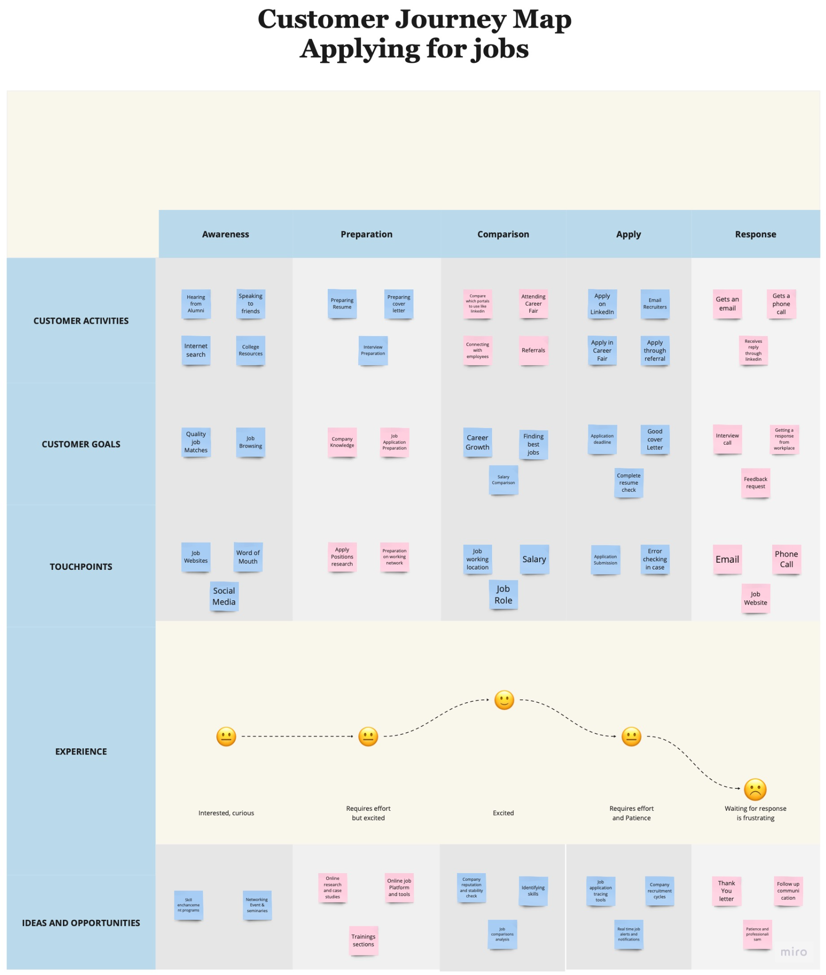

## **Design Solution:**

This section contains various design solutions like Sitemap, Screenflow and wireframes. All these solutions aim to address the lack of real-time updates that candidates face, and create seamless communication and engaging experience for candidates and recruiters while minimizing potential frustrations during the waiting period.

### **Proposed Solution:**

A possible solution would be a straightforward and easy way for recruiters to communicate the recruitment process to candidates, time expectations and provide real-time updates as the process continues. This could be called “Recruitment Timeline”. This will help address the first pain point from recruiters and candidates which is communicating in a transparent and timely way about the recruitment process and updates. Recruiters will be able to share the timeline and invite candidates to be a part of it. Recruiters will be able to communicate with the candidates in a timely manner if they are moving forward with their applications to the next phase of the job process or if the candidates have not been selected.

### **Sitemap:**

The sitemap of this job portal outlines the structure and navigation of the online website providing a clear and organized overview of the different sections and pages that candidates may interact with during the application process and waiting period.

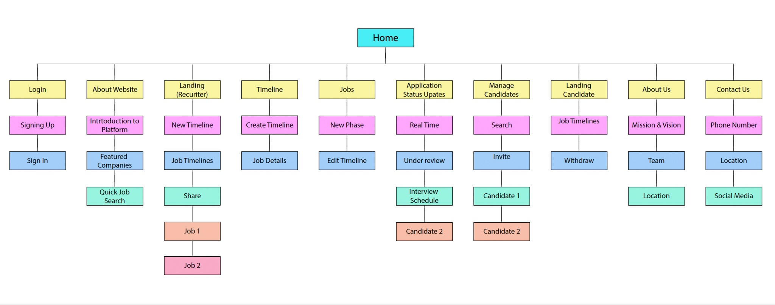

### **Screenflow:**

This section contains the screenflow for our proposed solution and outlines the sequential steps and interactions that recruiters and candidates experience while navigating through the online application process. To access the screenflow, please click [here](https://miro.com/app/board/uXjVNaNjEb0=/?share_link_id=487705386721).

### **Wireframes:**

Through our brainstorming sessions and taking into account our research, we narrowed down the core features for our wireframes that would bring the most value to the users.

Series of steps that the recruiters and candidates can take while navigating through the wireframes:

**Recruiters:**

1. Create a recruitment process timeline for the job they are hiring for.
2. Invite potential candidates to be a part of this timeline so they can see the candidates in different phases.
3. Can manage the candidates and move them across the timeline phases.
4. Have access to all the job timelines they have created for different job posts anytime

**Candidates:**

1. Candidates can see the recruitment process timeline for the job they want to apply for.
2. When invited to a timeline, they can see which phase of the job process they are in.
3. If they are not selected to move forward, they will be notified by the recruiter.
4. They can see all the timelines they were invited to be part of.
5. They can withdraw from any timeline if they want to.

To access the prototype, please click [here](https://drive.google.com/file/d/1-CeuHXs4nD1AhRBbKcY9Gban0ccFI1nz/view?usp=share_link)

## **User Testing:**

We conducted user testing with 1 recruiter and 2 candidates to test our website and we were able gather data and feedback from the users. Below are the tasks that the users were asked to complete.

Task 1: You want to post a new job opening that was recently opened in your company including the details about the company, the role, and the phases involved in the job process.

Go to the EzJob site and post a new job opening.

Task 2: You want to check the status of a resume that you recently submitted to a company.

Go to the EzJob site and check the status of your resume.

Task 3: You want to invite candidates to a job posting and add/remove them across different phases in the job process.  
  
Go to the EzJob site and invite candidates to your job timeline.

### **Feedback:**

* Testers identified certain ambiguities in the job portal's phases page.
* The recruiter told that EzJob would be a great integration to his recruitment portal.
* Job Seeker (Participant 1) mentioned that he would use EzJob for real-time updates on recruitment, timings, and the interview progress.
* Job Seeker (Participant 2) specified that feedback from the recruiters would be a great addition to the website.

### **Script:**

Thank you for participating in this user testing session for the EzJob application. The purpose of this study is to learn how to improve the usability of the website we are designing. We are in the early stages of designing a website that aims to create a user-friendly portal to facilitate seamless communication between recruiters and job seekers. Our job portal allows companies to post job openings and interact with potential candidates. Job seekers can also track the progress of their applications, providing them with real-time status updates. We are going to give you some tasks to do and in the process, we want to gather feedback as you work on the website. If you have any questions please feel free to ask. Now, we will begin the first task.

**Questions after User Testing:**

1. What parts of the website or tasks did you find difficult to use or navigate?
2. Is there anything you would like to add or change on the website to make it better?
3. Which part of the interface were you not familiar with or needs some improvement, whether in terms of functionality or usability?
4. Was it easy to post a Job opening outlining the requirements specified by the client?
5. Were you able to perform tasks, such as searching for jobs or posting openings, without any issues?
6. What do you think sets "EzJob" apart from other job portals you've used or heard about?

## **Revision:**

While testing our job portal, users pointed out some confusion on the phases page. To address this, we redesigned and updated a few slides, mainly focusing on the phases section. We noticed that both recruiters and candidates faced difficulty navigating through it. To make things clearer, we added descriptions to the phases page, which helped users better understand its functionality. We also included different functionalities like Edit Timeline, Manage Candidates to the webpages so the users would have more options while navigating through the website. A recruiter pointed out that Edit Timeline would save them time instead of creating new timelines everytime. We also included a functionality where the recruiter will be able to move the candidates across different phases of the job application process and add new candidates using their email. Additionally, we included headings for each of the phases, providing a straightforward guide for everyone using the portal.

## **Final Prototype:**

Our final prototype is like the finished masterpiece of all our hard work. It brings to life the very first ideas we had and how they've grown. It's the exciting result of turning thoughts into something you can see and interact with!

<https://www.figma.com/proto/wi8j2M6BJmlILy9hVrAl8a/UX-Project?type=design&node-id=1-3&t=EkLR8i7NtN5z73ok-1&scaling=min-zoom&page-id=72%3A314&mode=design>

## **Reflection:**

* We were able to solve the underlying problem related to job applications which is real-time updates between recruiters and candidates.
* Our main challenge was to prioritize the features we brainstormed during the planning phase. We had a lot of ideas but choosing most important features was a challenge
* Through User Testing, we identified some issues with our design as the users struggled to navigate through the website.
* A key suggestion we received is to integrate feedback mechanisms into the website.
* Potential improvements to include in the future:
  + Feedback from recruiters
  + Adding templates for timelines so that recruiters can easily create timelines.
  + Adding new phase button in the middle of different phases

## **Conclusion:**

In wrapping up, our project takes on a common frustration in the job application process – the waiting game. We've all been there, feeling left in the dark about our application status, dealing with prolonged uncertainty, and that nagging anxiety. We get it; it's tough for both applicants and HR professionals.

We crafted a solution aimed at making communication a breeze throughout the application journey. Why? Because we want to ease the stress for job seekers and help HR teams provide feedback faster.

To sum it up, our solution is here to make the job application process better. Picture less waiting, clearer communication, and a lot less stress about where you stand. It's not just about fixing a problem; it's about making the whole experience positive and supportive for everyone navigating the hiring journey.

## **Appendix:**

### **Interview Questions:**

1. Do you feel it takes too long to hear back from recruiters or workplaces after sending a resume?
2. What do you think should be the ideal timeline for the entire hiring process?
3. Did you face any unexpected obstacles during your job search, and how did you overcome them?
4. Did you have any conversations with the hiring person about the reasons behind the extended timeline?
5. Do you think you are losing quality applications due to poor communication and a slow hiring process?
6. What are the common reasons why the hiring process is delayed?
7. What strategies or techniques did you find most effective in finding job opportunities?
8. Are you concerned that the delay in the hiring process may affect other job opportunities? How can you manage multiple job prospects when facing delays from one of them?
9. Are there tools and technologies that would streamline and manage the hiring process more effectively?
10. What security measures or privacy settings would you want in place to protect your information?
11. How do you feel about employer reviews and ratings being integrated into a job portal?
12. What types of communication channels do you prefer for updates on job applications?